Written Test: SCIENCE
Name & Surname: _____________________________ 1st “B”

Objectives:
Students should be able to:
- Make a table of results.
- Interpret line graphs and pie charts.
Plot line graphs and pie charts according to Cambridge’s regulations.

- Read the following data and answer the questions.
- Which activity is least popular among the fifth graders?
- What percentage of students like surfing?
- Which two activities are equally popular?
- What percentage of students like an activity other than sandcastle building?

- “A gust of wind caught a clown’s balloon bouquet and all of his balloons flew off. 25 of them were blue, 46 were red, 20 were yellow and only 8 were golden”

- How many balloons had the clown’s bouquet?
- Plot a pie chart and show your calculations.

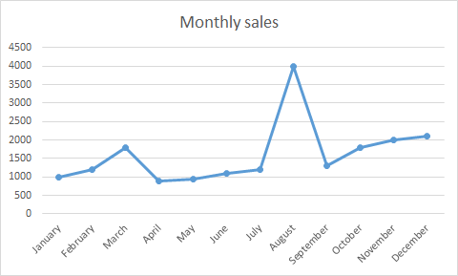
- a) What has been plotted here?
b) How many sales were there in May and in November?
c)

